Click on the title or logo to find the sign in page

Busythings
Busythings is an online learning resource for the early years that includes 115+ fun activities that help children learn important skills in key areas such as Literacy, Numeracy, Computing, Creative Development, Art and Music. Its quirky characters are fun and engaging retaining children’s interest as they learn. We now also have access to a special new section for children aged 7-11 years old.
This subscription service has been provided through Better Beginnings supporting families in sharing a love of reading.

Literacy Planet
A high-quality play-based literacy resource with more than 10,000 activities online for children of all ages and ability.
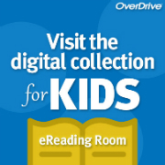 | OverDrive - eReading Room for Kids  OverDrive eReading Room just for kids provides a safe and easy browsing experience for children. The eReading Room just shows children's content, which gets kids to the titles they want faster. Kids can browse, sample, place holds and borrow eBooks appropriate for their age range and reading level.
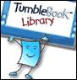 | TumbleBookLibrary  Introduce young children to the joys of reading with this delightful collection of animated, talking picture books.  This subscription service has been provided through Better Beginnings supporting families in sharing a love of reading.
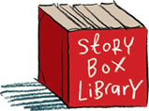 | StoryBox Library  A place where the wonderful world of Australian Children's Literature is on permanent exhibit Story Box Library in a beautiful online ‘reading room’. Story Box Library connects children with literature through the complementary medium of film, providing our audience with a vibrant, interactive experience via a diverse range of storytellers, each sharing past and present book titles.

