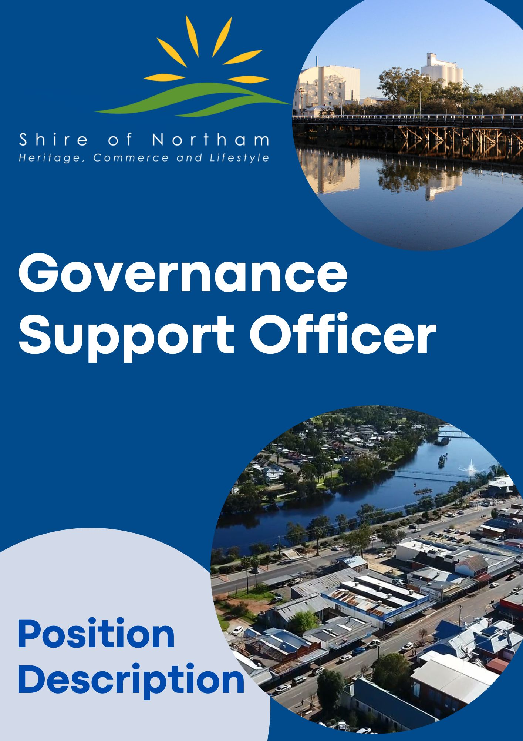

***Position Summary***

**Reports to:** Manager Governance and Risk

**Department:** Office of the CEO

**Objective:** To assist the Governance & Risk Team in ensuring the smooth, effective, and timely management of the Shire’s corporate governance and risk functions.

A high degree of confidentiality and professionalism is essential for this role.

**Work Location:** Shire Admin Building

**Award/Level:** 6/1

**Date Revised:** September 2025

**Outcomes**

**Meeting Administration**

* Coordinate, compile, and distribute agendas and minutes for meetings of Council and relevant committees.
* Coordinate, attend, and provide support for meetings of Council and relevant committees, including minute taking.
* Coordinate advisory committee reports to Council as required.
* Coordinate receipt of petitions in accordance with guidelines when required.
* Prepare status reports on Council resolutions.
* Support elected members and staff in the effective use of agenda, minutes, and distribution software (Doc Assembler and Docs on Tap), and provide training when required.
* Liaise with staff to obtain information for responses to questions from Council Members and members of the public during Public Question Time, deputations, and petitions.
* Provide support and assistance with local government elections.

**Governance Administration**

* Provide administrative support to the Manager Governance and Risk and Governance and Risk Officer with tasks associated with compliance, assurance, risk management, business continuity, contacts, procurement, and any other function applicable to Governance and Risk functions when required.
* Assist with the production and collation of reports and documents relating to the Governance business unit.
* Provide customer-focused support to elected members when required, including annual training and development program.
* Facilitate the completion of regulatory and statutory returns, primary and annual returns, annual compliance audit returns, and related party returns when required.
* Update and maintain databases and registers including, but not limited to, complaints, delegations, gifts, legal/lease documents, training, and conferences.

**Other**

* Provide cover for the Governance and Risk Officer during periods of leave.
* Ensure record keeping function for Governance and Risk documentation is undertaken in accordance with the Shire’s Records Management Policy and the State Records Act 2000.
* Preparation and maintenance of the Shire’s Record Keeping Plan, and that the records system is compliant with all relevant legislation.
* Ensure appropriate record indexing and classification and manage appropriate retention and disposal plans for all records.
* Assist staff and the public in the retrieval of information from the Shire’s records including assistance with Freedom of Information enquiries.
* Ensure all incoming documents (includes emails/ cheques) are opened, registered, classified, attached to files and assigned to officers daily for action. Ensure all outgoing documents are filed correctly.
* Provide all staff with a Records Management Induction, providing information on applicable policies and procedures for records management and provide ongoing training and support for all staff with their record-keeping responsibilities.
* Assist with the updating and maintenance of the Shire website.
* Any other duties as directed by the Manager Governance and Risk or CEO as they pertain to the Governance and Risk business unit.

**Organisational**

* Embrace, support and participate in change to assist in achieving the Shire’s goals and objectives.
* The ability to maintain strict confidentiality is an essential requirement of all employees of the Shire.
* Actively participate in the ongoing development, compliance and promotion of professional customer service standards.
* Recommend changes or strategies which promote a ‘Continual Improvement’ and ‘Best Practice’ approach to service delivery.
* Promote, maintain, and improve the working environment and practices to ensure compliance with Industrial Awards, Work Health and Safety, Diversity Equal Employment Opportunities (EEO) legislation and Council’s Policies and Procedures.

**Work Health and Safety, Employee Requirements**

Employees are responsible and accountable for:

* Complying with workplace procedures for risk identification, risk assessment and risk control
* Participation in activities associated with the management of workplace health and safety.
* Identification and reporting of health and safety risks, accidents, incidents, injuries, property damage and mishaps at the workplace.
* Correct utilisation of appropriate personal protective equipment

|  |  |  |
| --- | --- | --- |
| **POSITION REQUIREMENTS** |  |  |
| **Documents** | **Essential** | **Desirable** |
| * Hold a current unrestricted C Class national drivers licence |  |  |
| * Provision of a current National Police Clearance |  |  |
| **Skills and Abilities** |  |  |
| * Ability to liaise with people at all levels in an informative and positive manner. |  |  |
| * High level of numeracy and accuracy skills |  |  |
| * High level of computer literacy and proficiency including use of Microsoft Office Suite. |  |  |
| * Well developed written and verbal communications skills. |  |  |
| * Proven time management skills with the ability to work under pressure, and be well organised. |  |  |
| * Sound judgement and problem solving skills. |  |  |
| * Ability to undertake other administration tasks (eg agenda preparation, updating templates |  |  |

**GENERAL PHYSICAL REQUIREMENTS**

|  |  |  |  |  |
| --- | --- | --- | --- | --- |
|  |  |  |  |  |
| **Task** | **Mainly** | **Frequently** | **Occasionally** | **N/A** |
| Stand |  | √ |  |  |
| Walk |  |  | √ |  |
| Sit |  | √ |  |  |
| Handle |  |  | √ |  |
| Reach |  |  | √ |  |
| Climb/Balance |  |  | √ |  |
| Crouch/Kneel |  |  | √ |  |
| Talk/Hear |  | √ |  |  |
| Tast/Smell |  |  | √ |  |
|  |  |  |  |  |

**Authorisation and Acknowledgement**

|  |
| --- |
| I acknowledge that I have read and understood the key objectives, duties, responsibilities and other requirements as outlined in this position description.  I understand that this position description provides general guidance regarding the purpose of the position and my responsibilities.  Furthermore, I acknowledge that this position description may be amended from time to time to reflect changes to the position or Shire requirements. |
| Employee Signature: Date: |

