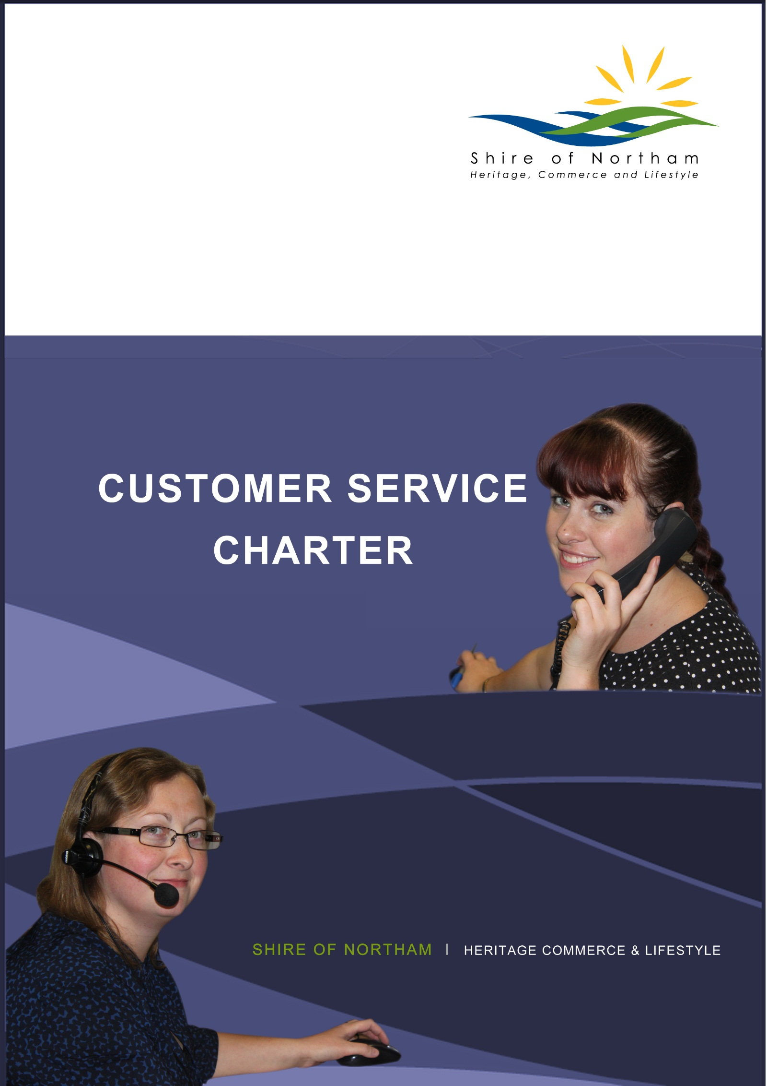

**INTRODUCTION**

This Customer Service Charter outlines the Shire of Northam’s commitment to providing you (the community) with quality services and includes a clear guide to measure our performance. The Charter sets the minimum standards our employees should adhere to.

**OUR VISION**

Is for a vibrant growing community that is safe, caring and inclusive. A community that values our heritage, preserves our environment and promotes our commerce.

In order to achieve this Vision, the Council will commit to display;

* ***LEADERSHIP***
* *to recognise the community’s expectations to provide leadership*
* ***RESPECT***
* *to respect difference in age, culture, values and opinion*
* ***TEAMWORK***
* *to achieve through the efforts of the team*
* ***EXCELLENCE***
* *to aspire to one standard*
* ***OPENNESS***
* *to engender trust through openness*

**OUR MISSION**

**

Our cultural change emblem which includes an acronym of the values and behaviours we want embedded in our culture will remind us to soar high in our aspirations and work together as an organisation to achieve them.

To deliver responsive, sustainable services in a manner that preserves and enhances our environment and lifestyle whilst respecting our heritage and facilitating economic growth.

In order to achieve this Mission , the Organisation will commit to being;

* ***SAFE***
* *focus on importance of safety in the organisation*
* ***OPEN***
* *engage in two way communication, with transparency and trust*
* ***ACCOUNTABLE***
* *know what you are responsible for, take ownership and deliver accordingly*
* ***RESPECTFUL***
* *demonstrate respect for other’s skills, knowledge and differing value systems*

**SERVICE STANDARDS YOU CAN EXPECT FROM US**

As a customer you are entitled to:

* prompt, courteous, friendly and professional service;
* be treated with respect;
* have your concerns addressed promptly;
* have your business processed in a timely manner;
* receive accurate and timely information;
* participate in the community decision making process;
* access to all services and amenities provided by the Shire; and
* have your feedback used as an opportunity to improve our services.

**OUR STANDARDS**

The Shire of Northam’s Customer Service Charter requires all officers to be competent, approachable and courteous at all times and we will do this by:

* wearing a name badge when assisting customers;
* treating all people as individuals, endeavoring to identify them by name;
* ensuring staff are multi-culturally aware;
* being positive, friendly, supportive and helpful;
* listening to people’s views and opinions;
* focusing on what we can do, not what we can’t do;
* ensuring people who have special needs are able to access our services;
* answering calls in a courteous manner;
* returning telephone calls within 48 hours;
* responding to all letters within seven (7) working days or providing an acknowledgment and explanation for the delay;
* responding to complaints/concerns within ten (10) working days;
* officer acknowledgment advising your concerns have been finalised;
* asking for clarification where necessary to ensure community needs are understood and can be met;
* maintaining up-to-date knowledge of services and amenities;
* ensuring staff are familiar with the vision and goals of the Shire’s Strategic and Corporate Plans;
* making all attempts to resolve issues to the mutual satisfaction of the person and the Shire;
* referring any enquiry they cannot answer to an appropriate officer;
* ensuring an appropriate message is recorded and delivered;
* ensuring all enquiries where a commitment has been made are followed up and the person is advised of the outcome;
* looking for opportunities to provide better service to the community;
* keeping you informed about the progress of your business with the Council; and
* writing our brochures, publications and correspondence in clear language;

The Shire is being driven by principles of quality improvement which means continuously improving our processes including documenting our processes and procedures.

**YOU CAN ASSIST US BY**

* providing accurate and complete details when you contact us with any queries or requests for assistance;
* phoning to make an appointment if you have a complex enquiry or need to see a specific officer;
* phoning the officer nominated on correspondence sent to you and quoting the reference number on the letter;
* being clear and concise with your requests and being prepared with relevant information;
* treating Employees with the same courtesy and respect given to you; and
* acknowledging that the Shire may not have the authority to deal with your request or complaint and may need to refer it to another agency/organisation.

**WHAT YOU CAN DO FOR US**

You can help us to meet our commitments to you by:

* being courteous, polite and respectful of our employees;
* letting us know when your situation changes, for example; change of address, change of details for your registered animal;
* contacting the shire to make an appointment if you have a complex or technical enquiry, or need to meet with a specific employee;
* working with us to help solve problems; and
* Providing us with feedback/compliments/suggestions to help us improve our services.

**WHAT IF YOU DON’T GET THE SERVICE YOU DESERVE?**

Council has a designated complaints officer who will be your voice within Council and will endeavour to achieve a satisfactory solution for you. The complaints officer will investigate serious complaints via our Customer Request System and advise you of the progress within ten (10) working days.

**YOUR PRIVACY**

At all times we will respect your privacy when dealing with us and the confidentiality of the information discussed. We will treat your personal information collected by us in the strictest confidence.

**FREEDOM OF INFORMATION (FOI)**

The Western Australian *Freedom of Information Act 1992* provides you the right to apply for access to documents held by state public sector agencies, which includes local governments. For further information please contact the Shire on 9622 6100.

**CONTACT US**

Our office hours are from 08:30 until 4:30pm for Administration. Licencing is from 08:30 to 4:00pm

You may call 9622 6100 or visit our administration centre, recreation centres or libraries to complete a Customer Feedback Form.

You are welcome to attend the office; phone us or email the Shire via: [records@northam.wa.gov.au](mailto:records@northam.wa.gov.au)

You can even write to us and address the appropriate officer; records or

Mr Jason Whiteaker

Chief Executive Officer

PO Box 613

NORTHAM WA 6401



**CUSTOMER FEEDBACK FORM**

|  |  |  |
| --- | --- | --- |
| Date: _________________ | Time: _________________ | File ref: ___________ |

Customer Contact: (please circle) In person Telephone Written Email

**Customer Details** (this is you):

NAME

ADDRESS

TELEPHONE Home Mobile

Email

**If you would like to compliment a staff member, please provide their name and position if known and details of why you would like to compliment them:**

|  |
| --- |
|  |
|  |
|  |
|  |
|  |
|  |
|  |
|  |

**If this is a Complaint please supply the following details** (this is where the problem is**):**

Name person (if available) you are complaining about: ______________________________________________

Address where problem occurring (compulsory):

Type of Complaint: Noise Untidy Burning Poultry Other __________________________________(please circle)

Date of Incident Time of Incident

**Office Use only**

Name of Person taking complaint ________________ Department ___________________________

**Use for further information if required**



**CUSTOMER FEEDBACK FORM**

|  |  |  |
| --- | --- | --- |
| Date: _________________ | Time: _________________ | File ref: ___________ |

Customer Contact: (please circle) In person Telephone Written Email

**Customer Details** (this is you):

NAME

ADDRESS

TELEPHONE Home Mobile

Email

**If you would like to compliment a staff member, please provide their name and position if known and details of why you would like to compliment them:**

|  |
| --- |
|  |
|  |
|  |
|  |
|  |
|  |
|  |
|  |

**If this is a Complaint please supply the following details** (this is where the problem is**):**

Name person (if available) you are complaining about: ______________________________________________

Address where problem occurring (compulsory):

Type of Complaint: Noise Untidy Burning Poultry Other __________________________________(please circle)

Date of Incident Time of Incident

**Office Use only**

Name of Person taking complaint ________________ Department ___________________________

**Use for further information if required**