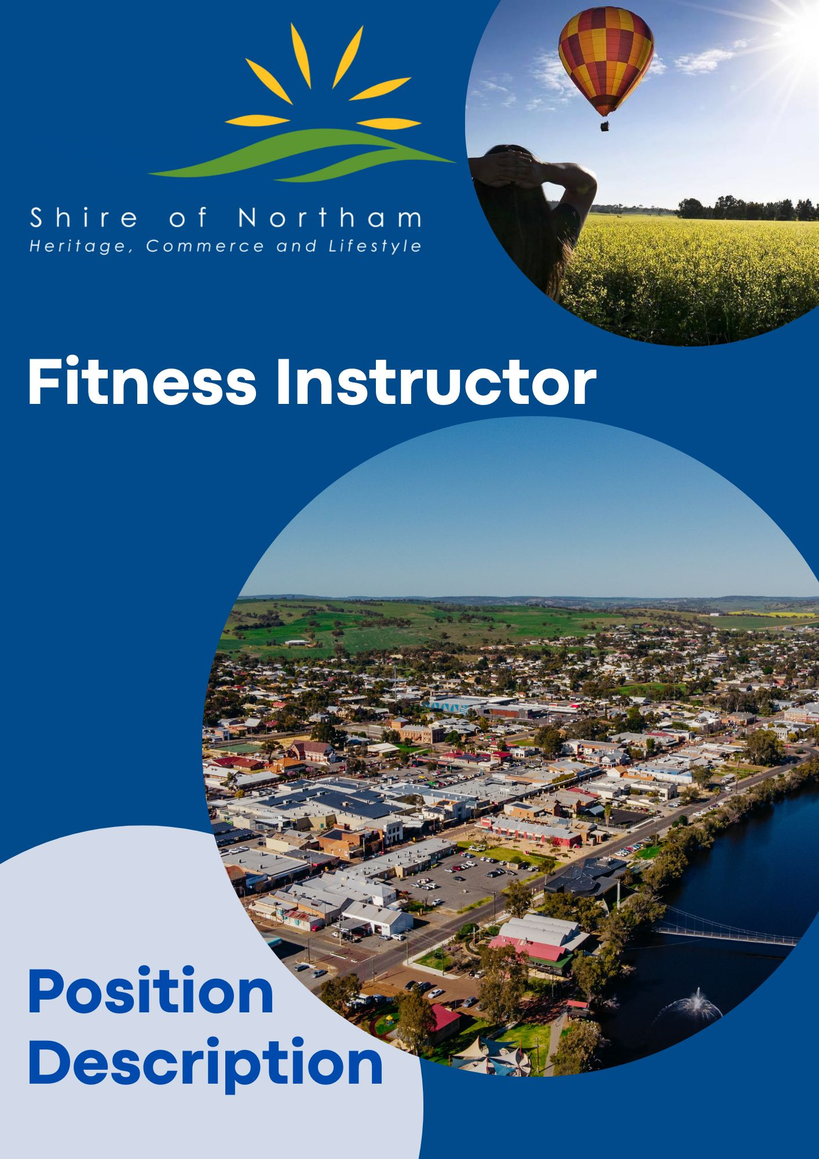

**Fitness Instructor**

***Position Summary***

**Reports to:** Recreation Services Coordinator / Manager Recreation & Youth Services

**Department:** Community Services

**Job Title:** Fitness Instructor

**Objective:** To provide practical and theoretical knowledge of sports and fitness through training programs and fitness classes.

**Work Location:** Recreation Centre and Northam Aquatic Facility

**Award/Level:** 3/1

**Date Revised:** 7th September 2023

**Responsibilities and Duties**

**Position**

* Planning and conducting fun, safe and effective aerobics and circuit fitness classes
* Explaining exercises and demonstrating how to perform them correctly
* Designing exercise routines and workouts to suit all ages, abilities and needs
* Helping course participants during exercise routines and workouts and checking they are performing exercises correctly
* Evaluating course content and modifying it where necessary
* Motivating clients to improve their performance & continue with their training programs
* Checking to ensure that exercises and equipment are performed/used safely
* Set up and pack away equipment before and after classes.
* Ensuring all fitness equipment is in perfect working order
* Ensuring that the workout area is clean and tidy
* Encouraging clients to lead an active, healthy lifestyle
* Providing first aid, where necessary
* Carry out Administration duties (including writing class descriptions).

**Skills & Qualifications**

* Certificate 3 in Fitness
* Practical and theoretical knowledge of sports and fitness
* Ability to design training programs
* Ability to reach sports and fitness activities
* Knowledge of fitness and training equipment
* Ability to assess a client’s level of physical fitness and potential
* Knowledge of first aid methods
* Energy, enthusiasm and dynamism
* Time management skills
* Strong interpersonal skills
* Excellent physical fitness

**Organisational**

* Embrace, support and participate in change to assist in achieving the Shire’s goals and objectives.
* The ability to maintain strict confidentiality is an essential requirement of all employees of the Shire.
* Actively participate in the ongoing development, compliance and promotion of professional customer service standards.
* Recommend changes or strategies which promote a ‘Continual Improvement’ and ‘Best Practice’ approach to service delivery.
* Promote, maintain and improve the working environment and practices to ensure compliance with Industrial Awards, Occupational Safety & Health, EEO legislation and Council’s Policies and Procedures.

**Occupational Safety & Health, Employee Requirements**

Employees are responsible and accountable for:

* Complying with workplace procedures for risk identification, risk assessment and risk control
* Participation in activities associated with the management of workplace health and safety.
* Identification and reporting of health and safety risks, accidents, incidents, injuries, property damage and mishaps at the workplace.
* Correct utilisation of appropriate personal protective equipment

|  |  |  |
| --- | --- | --- |
| **POSITION REQUIREMENTS** |  |  |
| **Documents** | **Essential** | **Desirable** |
| * Hold a current unrestricted C Class national drivers licence |  |  |
| * Provision of a current National Police Clearance |  |  |
| **Skills and Abilities** |  |  |
| * Ability to liaise with people at all levels in an informative and positive manner. |  |  |
| * High level of numeracy and accuracy skills |  |  |
| * High level of computer literacy and proficiency including use of Microsoft Office Suite. |  |  |
| * Well developed written and verbal communications skills. |  |  |
| * Proven time management skills with the ability to work under pressure, and be well organised. |  |  |
| * Sound judgement and problem solving skills. |  |  |
| * Ability to undertake other administration tasks (e.g. agenda preparation, updating templates). |  |  |

**GENERAL PHYSICAL REQUIREMENTS**

|  |  |  |  |  |
| --- | --- | --- | --- | --- |
|  |  |  |  |  |
| **Task** | **Mainly** | **Frequently** | **Occasionally** | **N/A** |
| Stand | √ |  |  |  |
| Walk | √ |  |  |  |
| Sit |  |  | √ |  |
| Handle |  | √ |  |  |
| Reach |  | √ |  |  |
| Climb/Balance |  | √ |  |  |
| Crouch/Kneel |  | √ |  |  |
| Talk/Hear | √ |  |  |  |
| Tast/Smell |  |  |  |  |
|  |  |  | √ |  |

**Authorisation and Acknowledgement**

|  |
| --- |
| I acknowledge that I have read and understood the key objectives, duties, responsibilities and other requirements as outlined in this position description.  I understand that this position description provides general guidance regarding the purpose of the position and my responsibilities.  Furthermore, I acknowledge that this position description may be amended from time to time to reflect changes to the position or Shire requirements. |
| Employee Signature: Date: |

