Wundowie Library
Rhyme Time
for babies & toddlers

Open Shut Them
Open, shut them
Open, shut them
Give a little clap
Open, shut them
Open, shut them
Lay them in your lap
Creep them, creep them
Creep them, creep them
Right up to your chin
Open wide your little mouth…
But do not let them in!
Rolle them, roll them
Roll them, roll them
Roll them just like this
Shake them, shake them
Shake them, shake them
and blow a little kiss

1
Stretching
When I stretch up, I feel so tall. (Reach high)
When I bend down, I feel so small. (Bend over)
Taller, taller, taller, taller. (Reach up high and higher.)
Smaller, smaller, smaller, smaller. (Get low on the floor.)
Into a tiny ball. (Sit down.)

Row, row, row your boat

Row, row, row your boat

Gently down the stream

Merrily, merrily, merrily, merrily

Life is but a dream

2
Baby’s nap
This is a baby ready for a nap. (hold up index finger)
Lay him down in his mother’s lap. (place finger on open palm of other hand)
Cover him up so he won’t peep. (wrap fingers around finger)
Rock him till he’s fast asleep. (rock hands back and forth)

Bears Eat Honey
A bear eats honey (pretend to eat)
He thinks it’s yummy
In his tummy (rub tummy)
But the bees don’t think it’s funny!
Buzzzzzzzzzzzz! (make buzzing noise)

3
This Is Big
This is big big big (Hold arms out to side)
This is small small small (Cup hands together)
This is short short short (Hold hands with palms facing each other)
This is tall tall tall (Reach one hand above head)
This is fast fast fast (Circle fists quickly)
This is slow slow slow (Circle fists slowly)
This is yes yes yes (Nod)
This is no no no (Shake head)

Melissa Depper

4
Round and Round the Garden
Round and round the garden like a teddy bear (swirl finger around palm)
One step, two step (walk fingers up child’s arm)
Tickle you under there! (tickle child’s underarm)

Round and round the haystack (Move fingers in walking motion around child’s tummy)
Went the little mouse
One step, two steps, (Walk fingers up body towards neck)
Into his little house (Tickle under neck)
Round and round the garden
Little bunny goes.
Hippity-hop, hippity-hop
He's gonna get your nose!

5
Miss Polly had a dolly

Miss Polly had a dolly who was sick, sick, sick

So she phoned for the doctor who came quick, quick, quick

The doctor came with his bag and his hat

And he knocked on the door with a rat-a-tat-tat

He looked at the dolly and he shook his head

Then he said “Miss Polly put her straight to bed”

He wrote on a paper for a pill, pill, pill

“I’ll be back in the morning with my bill, bill, bill”

6

Teddy Bear, Teddy Bear
Teddy bear, teddy bear, turn around
Teddy bear, teddy bear, touch the ground
Teddy bear, teddy bear, reach up high
Teddy bear, teddy bear, touch the sky
Teddy bear, teddy bear, touch your knees
Teddy bear, teddy bear, sit down please

7
Once I caught a fish alive
1,2,3,4,5 once I caught a fish alive
6,7,8,9,10 then I let him go again
Now why did you let him go?
Because he bit my finger so.
Which finger did he bite?
This little finger on my right.

Construction Worker Song
This is the way we pound our nails, pound our nails, pound our nails
This is the way we pound our nails, so early in the morning
Saw the wood
Turn the screwdriver
Drill a hole
Stack the bricks
Stir the paint
Paint the walls

8
Humpty Dumpty

Humpty Dumpty sat on the wall

Humpty Dumpty had a great fall

All the king’s horses and all the king’s men

Couldn’t put Humpty together again

Baa baa black sheep

Baa, baa black sheep

Have you any wool?

Yes sir, yes sir

Three bags full

One for the master and one for the dame

And one for the little boy who lives down the lane

9

Here's a ball for baby

Here's a ball for baby,
Big and soft and round. (Fingertips form a ball)
Here is baby's hammer,
See how he can pound. (Pound a fist on palm of other hand)
Here are baby's teddies,
Standing in a row. (Hold ten fingers erect)
Here is baby's music,
Clapping, clapping so. (Clap hands)

Eat an Apple

Eat an apple (bright right hand to mouth)

Save the core (close right hand in fist)

Plant the seeds (touch the ground)

And grow some more (extend arms up)

10
Incey Wincey

Incey Wincey spider

Climbed up the water spout

Down came the rain and

Washed poor Incey out

Out came the sunshine

And dried up all the rain

So Incey Wincey spider

Climbed up the spout again!

11
If you're happy and you know it (feeling version)

If you're happy and you know it
Clap your hands. Clap, Clap.
If you're happy and you know it
Clap your hands. Clap, Clap.
If you're happy and you know it
and you really want to show it
If you're happy and you know it
Clap your hands. Clap, Clap.

If you're angry and you know it
Stomp your feet. Stomp, Stomp.

If you're sad and you know it
Cry out loud. Boo hoo.

If you're scared and you know it
Give a shiver. Brrrr

If you're silly and you know it.
Laugh out loud. Ha ha ha

If you're friendly and you know it
Wave hello.

If you're sleepy and you know it
Give a yawn. Yawn

If you're excited and you know it
Shout hurray. Hurray.
12
Rock-a-bye your bear

Everybody clap,

(Clap! Clap! Clap!)

Everybody sing,

La la la la la!

Bow to your partner,

Then you turn around

Yipee!

Hands in the air,

Rock-a-bye your bear,

Bear's now asleep,

Shh! Shh! Shh!

Bear's now asleep,
Shh! Shh! Shh!

13
Twinkle, twinkle

Twinkle, twinkle, little star

How I wonder what you are

Up above the world so high

Like a diamond in the sky

Twinkle, twinkle little star

How I wonder what you are

When the blazing sun is gone
When he nothing shines upon
Then you show your little light
Twinkle, twinkle, all the night
Twinkle, twinkle, little star
How I wonder what you are

14
Heads and shoulders, knees and toes

Heads and shoulders, knees and toes

Knees and toes, knees and toes

Heads and shoulders, knees and toes

We all clap hands together

Eyes and ears and mouth and nose

Mouth and nose, mouth and nose

Eyes and ears and mouth and nose

We all clap hands together

15
The wheels on the bus

The wheels on the bus go round and round
Round and round, round and round
The wheels on the bus go round and round
All through the town

The horn on the bus goes beep, beep, beep
Beep, beep, beep, beep, beep, beep
The horn on the bus goes beep, beep, beep
All through the town

The wipers on the bus go swish, swish, swish
Swish, swish, swish, swish, swish, swish
The wipers on the bus go swish. swish, swish
All through the town

The people on the bus go bumpity, bump
Bumpity, bump, bumpity, bump
The people on the bus go bumpity, bump
All through the town

The wheels on the bus go round and round
Round and round, round and round
The wheels on the bus go round and round
All through the town

16
Grandma’s Glasses

These are Grandma’s glasses

This is Grandma’s hat

This is the way she folds her hands

And lays them in her lap

Here are Grandpa’s glasses

And here is Grandpa’s hat

And here’s the way he folds his arms

And takes a little nap

17
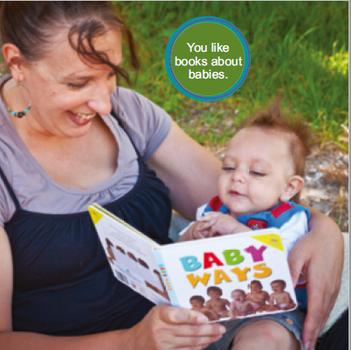

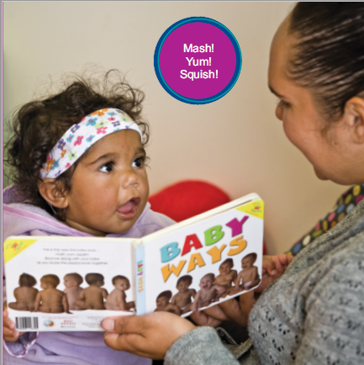

Pictures taken from “Talking together” http://www.health.wa.gov.au/docreg/education/population/child_health/growth_and_development/HP11285_talking_together.pdf
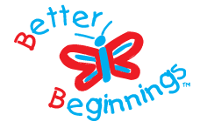

Songs, rhymes and fun for babies and their families

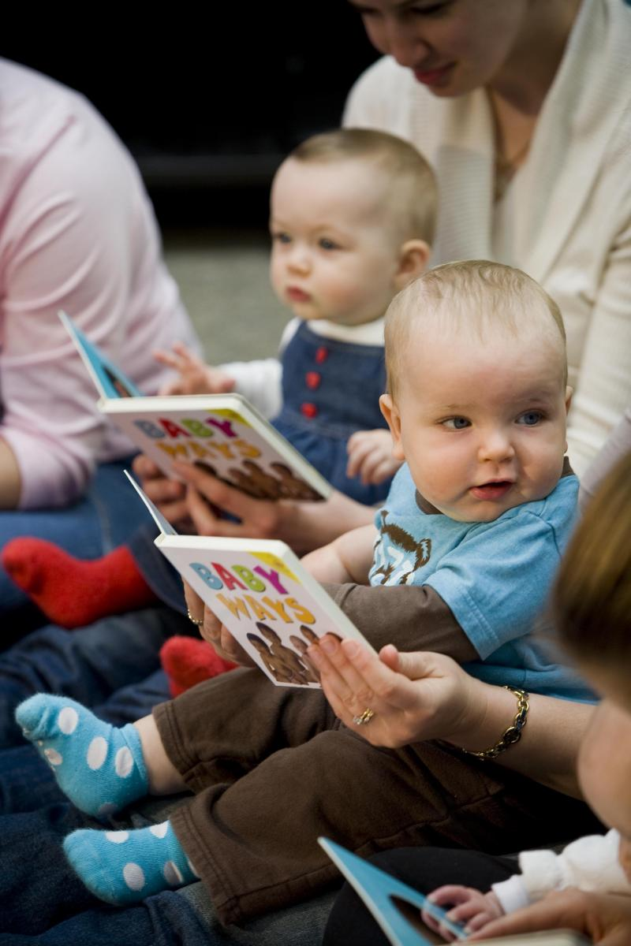

Come along to baby rhyme time and join in the fun as we sing songs and action rhymes, and share great books for babies
During sessions parents, grandparents and carers sit with their child and the group leader guides everyone through a selection of songs and rhymes. It's noisy, fun and a wonderful chance to learn some new songs for bedtime, bathtime or when you're stuck in the car.
Rhymes and songs are great for growing baby brains!

