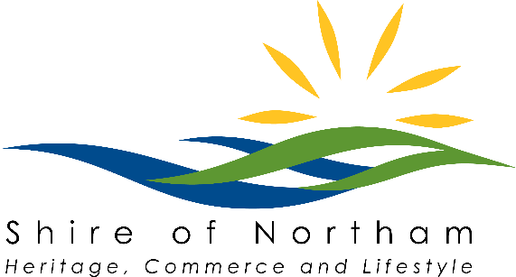

Request to Consume Liquor on Council Property

Name / Group | Click here to enter text.
Event / Function | Click here to enter text.
Location | Click here to enter text.
Date | Click here to enter a date.
Time | Click here to enter text.
Food available (provide details) | Click here to enter text.
Is there free potable drinking water available? | ☐Yes ☐No
Do the person/s selling or providing alcohol hold a valid Responsible Service of Alcohol (RSA) certificate? (if applicable) | ☐Yes ☐No
Please provide information in relation to how the crowd will be managed and controlled at the event or function (e.g. the practices to be used). | Click here to enter text.
Is the designated area for the sale and associated consumption of alcohol fully enclosed by a fence or other barrier (provide details)? | Click here to enter text.

Please refer to Council Policy A 8.6 Consent to Consume Liquor in or on a Council Property (Public Place) for more information.

